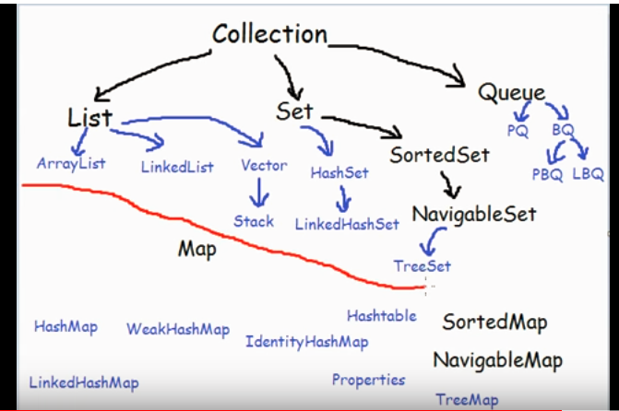

List: it is an interface and implements ‘Collection’ interface. It has the following characteristics:

1. It can contains duplicate values.
2. It preserves the insertion order

**ArrayList: It implements the List interface**